Evergreen International Conference

2018
The Evergreen International Conference brings together the decision makers of an ever evolving open source ILS used by thousands of libraries across the world.

  - St. Charles Convention Center, Missouri
  - April 30th-May 3rd, 2018
The 2018 conference will be held at the conveniently located St. Charles Convention Center. Join the Evergreen community for three days of programs, exhibits, and fun. Come join us at our next conference!

Champion Level Sponsorships $5,000
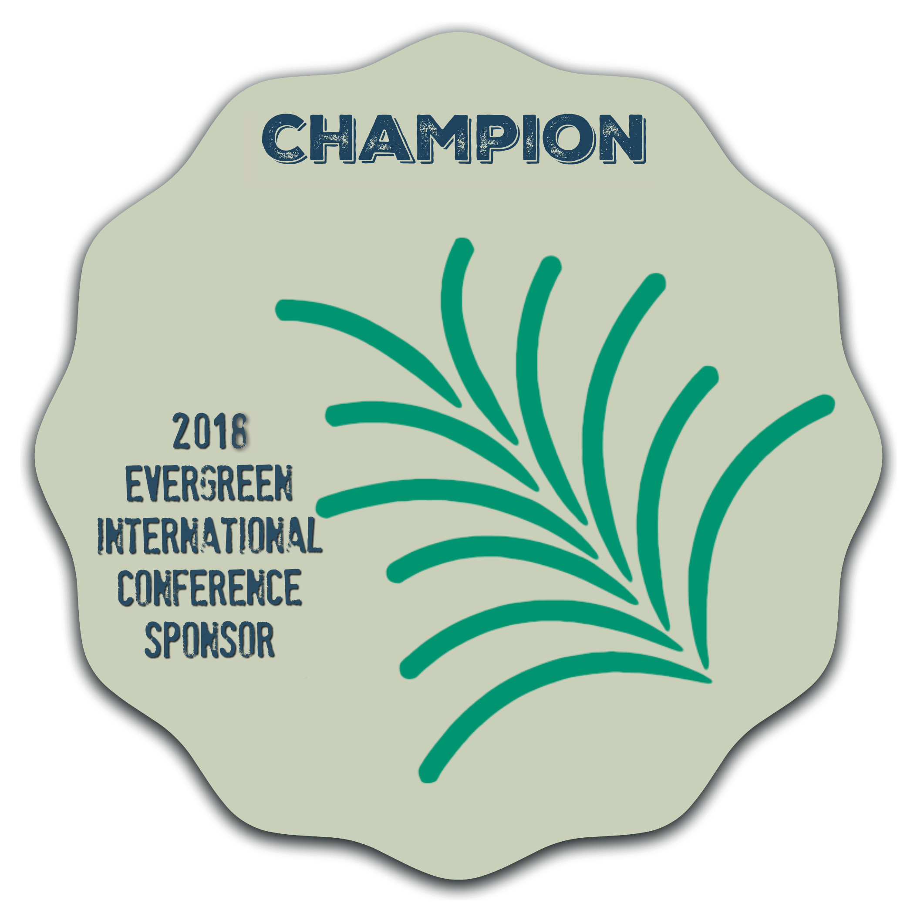 | Champions are our heroes! Their contributions ensure that the conference will be exceptional in all aspects. We appreciate you beyond measure!  By sponsoring at the Champion level, you automatically receive the following:  - Full page acknowledgment in the conference program  - Logo and link prominently displayed on the conference web site  - Two (2) free attendee registrations  - Acknowledgment in opening remarks each morning + closing remarks  - You also receive one of the additional perks listed below – Tote Bag, Reception, Badges, Pre-Conference Sessions with Lunch (first come, first served)  Tote Bag  Every conference attendee will receive a tote bag when they register for the conference. That tote bag will have your logo on it if you sign up for this sponsorship (1 available)  Reception  The hors d’oeuvres will be flowing and you can be responsible for so many happy stomachs! Consider sponsoring the Reception! Our conference team will make sure it’s an event to remember thanks to you! (1 available)  - Acknowledgment at the event  - Logo on signage at the event  - Acknowledgment on Twitter and Facebook on the day of your event  Badges  Feeling traditional? You can get high visibility with your logo on the badges for the conference. Hurry, this one goes fast! (1 available)  - Acknowledgment in the conference program  - Logo on the badges  - Acknowledgment on Twitter and Facebook  Pre-conference Sessions with Lunch  Evergreen attendees like to learn new things. Help us continue to offer important and topical sessions for in-depth learning. Feed attendees a tasty lunch! (1 available)  - Acknowledgment at the event  - Logo on signage at the event  - Acknowledgment on Twitter and Facebook on the day of your event

Advocate Level Sponsorships $2,500
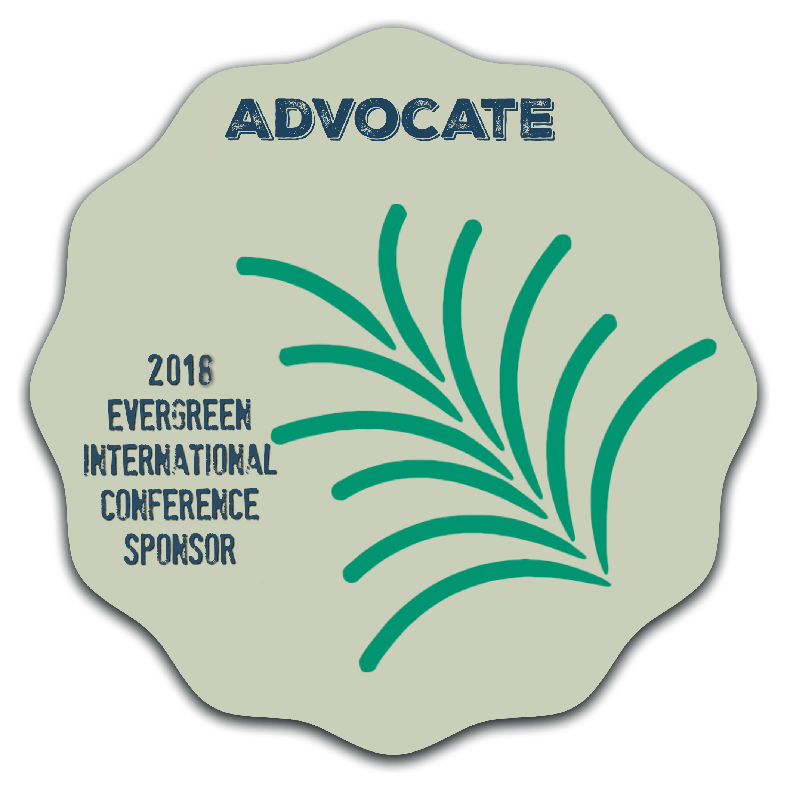 | The contributions of our Advocates allow us to do bigger and better things at every conference. You’re a welcome part of our community and we appreciate you.  By sponsoring at the Advocate level, you automatically receive the following:  - ¼ page acknowledgment in the conference program  - Logo and link displayed on the conference web site  - Acknowledgment in opening remarks  - Acknowledgment in the conference program  - You also receive one of the additional perks listed below – Breakfasts, Merchandise Table, Keynote Speaker, Program (first come, first served)  Breakfasts  Breakfast. The most important meal of the day. Enough said. (3 available)  - Acknowledgment at the event  - Logo on signage at the event  - Acknowledgment on Twitter and Facebook on the day of your event  Merchandise Table  We want to sell Evergreen themed shirts and mugs at the conference but the project doesn’t have the ability to print up and ship a large run of items. But if you sponsor the merchandise, we all win! Get a big sign on the merchandise table and a social media shout out every time we Tweet or Facebook about merchandise. (1 available)  - Acknowledgment in the conference program  - Your logo/name on the merchandise table  - Your logo on each piece of merchandise sold (on a removable sticker)  Keynote Speaker  Ensure that the conference starts off with a bang by sponsoring a great Keynote speaker. This session is attended by everyone and sets the tone for the entire conference. (1 available)  - Acknowledgment at the event  - Logo on signage at the event  - Acknowledgment on Twitter and Facebook on the day of your event  Program (Printing)  Help the attendees find their way to their programs and events! The printed program is a staple at every Evergreen conference and it will be at this one, thanks to you! (1 available)  - Acknowledgment at the event  - Acknowledgment in the conference program

Ally Level Sponsorships $1,250
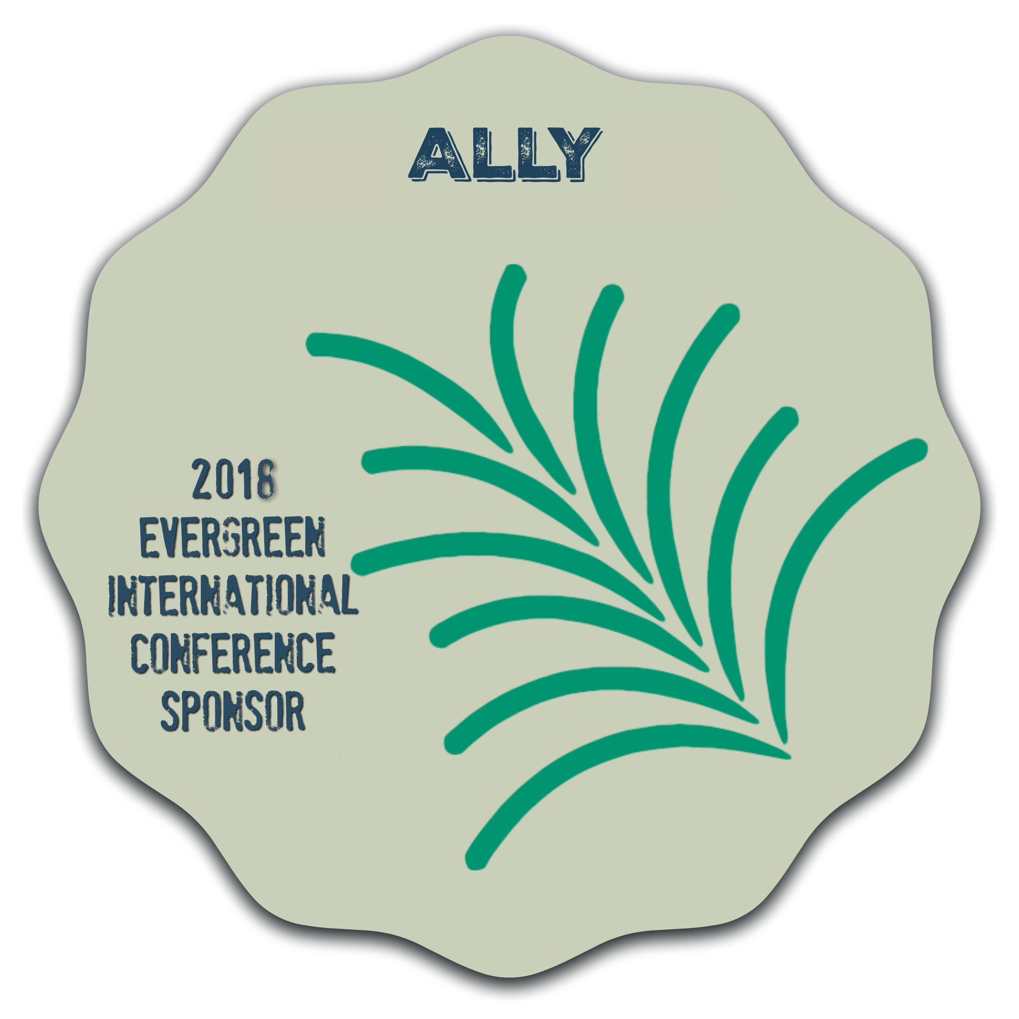 | Our Allies are an important part of the Evergreen Project. You’re aces in our book!  By sponsoring at the Ally level, you automatically receive the following:  - Logo and link displayed on the conference web site  - Acknowledgment during opening remarks  - Acknowledgments on Twitter and Facebook on your sponsorship days  - One piece of literature in tote bag - sponsor must provide literature in addition to sponsorship (5 available – first five to sign up will receive this)  - You also receive one of the additional perks listed below – Snack Breaks, A/V Support, Hackfest, Annual Report (first come, first served)  Snack Breaks  Want to provide some tasty treats? (3 available)  - Acknowledgment at the event  - Logo on signage at the event  - Acknowledgment in the conference program  A/V Support  Ensure that the programs at the conference are both seen and heard! A/V sponsorship is per day – your logo will appear on each session room’s signage for the day. (3 available)  - Logo and link on conference website  - Logo on room schedule signage  - Acknowledgment on Twitter and Facebook for every day you sponsor!  Hackfest  Ensure the community of software developers has plenty of power cords! (1 available)  - Acknowledgment at the event  - Logo on signage at the event  - Acknowledgment on Twitter and Facebook on the day of your event  Annual Report  Sponsor the creation and printing of the Evergreen Annual Project Report and you’ll get our undying gratitude and your logo on the report, too! (1 available)  - Acknowledgment in the conference program  - Acknowledgment at the Oversight Board Annual Report and update  - Your logo and acknowledgment on the back page of the printed report.

Exhibitor Information
Thank you for your interest in exhibiting at the 2017 Evergreen International Conference. We are planning another great year for conversations and connections in the exhibit area. Please don’t forget to look at our sponsorship opportunities for more chances to showcase your organization!

Our centrally located exhibits area provides constant contact with our attendees. Our exhibitors are also welcome to attend our meals, breaks, sessions, and entertainment opportunities.

Exhibitor Pricing and Information
Booth Pricing
Early Bird (until 2/1/2018) - $850
Standard (after 2/1/2018) - $975
Exhibit booth purchase includes one registration.
Additional early bird registrations are available at $220 per attendee (until 2/1/2018)
Additional standard registrations are available at $250 per attendee (after 2/1/2018)
Exhibit Times
- Monday noon-8pm (setup)
- Tuesday 8am-5pm (exhibit hours)
- Wednesday 8am-5pm (exhibit hours)
- Wednesday 5pm-7pm (tear down)

Included with your registration
- Centrally located booth area with carpet
- Wireless internet access
- One (1) 8-foot vinyl and skirted table
- Two (2) folding chairs
- One (1) small waste can
- One (1) standard electrical power strip

Please visit the conference website for more information including shipping and hotel information.
https://evergreen-ils.org/conference/2018-evergreen-international-conference/

All booth assignments will be on a first come, first served basis. Payment in full must be received no later than 30 days after form is received by the Conference or by 30 days prior to the event date, whichever comes first. Additional tables, chairs, supplies, or services must be requested 30 days in advance by emailing sponsors@evergreen-ils.org. Additional costs may apply.
By submitting this registration form, the sponsor acknowledges and agrees that the following conditions apply:
- No exhibit space may be sublet.
- No refunds will be extended for cancellations.
- The Evergreen International Conference, the Software Freedom Conservancy and the Embassy Suites by Hilton are not responsible for the safety of exhibits from theft, fire, or other causes.
- The exhibitor assumes responsibility for injury or damage to persons or property occurring within the exhibit space assigned to each exhibitor in accordance with the terms of this agreement.
- Exhibitors and their agents shall not deface or injure the walls or floors of the building, hotel, and conference area. Exhibitors will be liable to the hotel for damage.
- The Evergreen Oversight Board and Conference Committee reserves the right to request removal of any part of an exhibit deemed unsuitable by the Board or Committee.

Evergreen 2018 International Conference: Application & Agreement
Company Name | Contact Name
Street Address | Email Address
City/ State / Zip (Country) | Phone Number

Sponsors

Sponsorship Level: (check all that apply)
$5,000 Champion __ | $2,500 Advocate __ | $1,250 Ally __

Choose the function you wish to support from your sponsorship level.
Tote Bag __ | Breakfast __ | Snack Break __ | *If you desire to add registrations, please note them in the Exhibitors section below.
Reception __ | Merch Table __ | A/V Support __
Badges __ | Keynote __ | Hackfest __
Pre-Conference __ | Program Printing __ | Annual Report Printing __ | TOTAL: $ ________

Exhibitors
Early Bird (before 2/1/2018)  ___ booth(s) @ $850 per booth  ___ additional registrations(s) @ $220 per attendee  TOTAL: $ ___________________ | Standard (after 2/1/2018)  ___ booth(s) @ $975 per booth  ___ additional registrations(s) @ $250 per attendee  TOTAL: $ ___________________

Instructions and Payment  Form Instructions  Fill out Sponsor/Exhibitor Form Pages 1 & 2 and return to the Evergreen Conference Committee via email/fax/mail.  Option 1: Email to: sponsors@list.evergreen-ils.org  Option 2: Fax to: 203-577-4077 – Attn: Amy Terlaga  Option 3: Mail to: 24 Wooster Avenue, Waterbury, CT 06708  Attn: Amy Terlaga  If you have any questions about the opportunities available or the details of this form, please email sponsors@list.evergreen-ils.org  TOTAL: $___________  ___ Wire Transfer ___ Check  *Payment is due thirty (30) days from the date of signature. | Payment Instructions  The Evergreen Project is a member of the Software Freedom Conservancy, a non-profit organization that acts as a fiscal sponsor for free and open source software projects.  Methods of payment in order of preference:  - Wire transfer  - For domestic wire instructions, please email sponsors@list.evergreen-ils.org  - For international wire instructions, please email <accounting@sfconservancy.org>  - Paper Check - Paper Checks should be drawn in USD and made out to "Software Freedom Conservancy" then mailed to the following address. Please include a copy of this signed form with payment.  - Software Freedom Conservancy, Inc.  137 Montague St., Suite 380  Brooklyn, NY 11201-3548  Please note that due to our small size, we cannot accommodate requests for invoices for individual registrations. Send all other invoice requests to sponsors@list.evergreen-ils.org

**I have read and agree to all terms and conditions of this Application & Agreement. I warrant that I am authorized to sign on behalf of the sponsoring entity listed above and that all information provided is complete and accurate.

Signature Printed Name Title Date
Corporate Sponsorship Agreement - Terms and Conditions

This Agreement is between the Software Freedom Conservancy (``Conservancy'') and Sponsor. In consideration of the opportunity to participate as a sponsor of the Conference hosted by the Project [as indicated in the attached Price Schedule, incorporated herein by reference] in support of the Conservancy's mission to promote the use, development, and improvement of free and open source software, Sponsor agrees as follows:
SPONSORSHIP BENEFITS: Sponsor will receive the sponsorship benefits listed in the attached Price Schedule.
SPONSORSHIP PAYMENT: Sponsor agrees to make a payment specified in the Price Schedule.
CONSERVANCY EVENTS: Conservancy agrees not to schedule or sponsor any event in connection with the Project including, but not limited to, evening events, during a time that conflicts or overlaps with any official event scheduled during the Conference.
INDEMNITY AND LIMITATION OF LIABILITY: Neither the Conservancy, any co-sponsor, venue provider nor any of their respective officers, agents, employees, facilities, representatives, assigns, nor any volunteer otherwise affiliated with the Project shall be liable for, and Sponsor hereby releases them from, any claims for damage, loss, harm, or injury to the person, property or business of the Sponsor and/or any of its visitors, officers, agents, employees, or other representatives, resulting from theft, fire, earthquake, water, unavailability of the facility, accident or any other reason in connection with the Conference. The Sponsor shall indemnify, defend, and protect the Conservancy, its officers, directors, employees, agents, co-sponsors and venue providers harmless from and against any and all claims, demands, suits, liability, damages, losses, costs, attorney’s fees, and expenses that result or arise from Sponsor’s participation in the Conference or any actions of its officers, agents, employees, or other representatives. Under no circumstance will the Conservancy, any co-sponsor, or the venue provider be liable for lost profits or other incidental or consequential damages for any of their acts or omissions whatsoever, whether or not appraised of the possibility or likelihood of such damages or lost profits. In no event shall the Conservancy liability, under any circumstance, exceed the amount actually paid to it by the Sponsor. The Conservancy makes no representations or warranties regarding the Conference or its attendance.
OBSERVANCE OF LAWS: Sponsor shall abide by and observe all laws, rules and regulations, and ordinances in the performance of this agreement.
CANCELLATION OR TERMINATION BY CONSERVANCY: If for any reason beyond its reasonable control, including but not limited to fire, strike, earthquake, damage, construction or renovation to the display site, government regulation, public catastrophe, act of God, Conservancy shall determine that the Conference or any part will not be held, Conservancy may cancel the Conference or any part thereof. In that event, the Conservancy shall, upon written request by the Company, refund donations made in support of the Conference, after deducting any and all expenses incurred by the Conservancy. In this event, Conservancy will provide an accounting of Conference expenses incurred to all donors.
MISCELLANEOUS
Authority. Each Party represents and warrants that the execution, delivery and compliance with the terms of this Agreement by such Party and consummation by it of the transactions contemplated hereby have been duly and validly authorized by all necessary corporate or other action and the agreements contained herein constitute valid and legally binding obligations and are enforceable in accordance with their terms.
Waiver. The failure of either Party to insist on strict compliance with any of the terms, covenants, or conditions of this Agreement by the other Party shall not be deemed a waiver of that term, covenant, or condition, nor shall any waiver or relinquishment of any right or power at any one time or times be deemed a waiver or relinquishment of that right or power for all or any other times.
Enforceability. Each provision of this Agreement shall be separately enforceable, and the invalidity of one provision shall not affect the validity or enforceability of any other provision.
Governing Law. This Agreement shall be interpreted and construed in accordance with the laws of the State of New York.
Entire Agreement. This Agreement constitutes the only agreement, and supersedes all prior agreements and understandings, both written and oral, among the parties with respect to the subject matter hereof. This Agreement may not be amended or modified, except in writing and signed by all parties to this Agreement.

