Evergreen Batch Importing:
RDA test records
Good records to test the process are some RDA test records, which are available at
http://www.loc.gov/catdir/cpso/RDAtest/rdatestrecords.html
There are bibliographic and authority records available for testing. Using these records allows you to test the batch import process and to see how RDA records may look in Evergreen.
Download the RDA bibliographic records from either the Common Original Set or the Common Copy Set, or both.
Click on the file of test records you want to download.
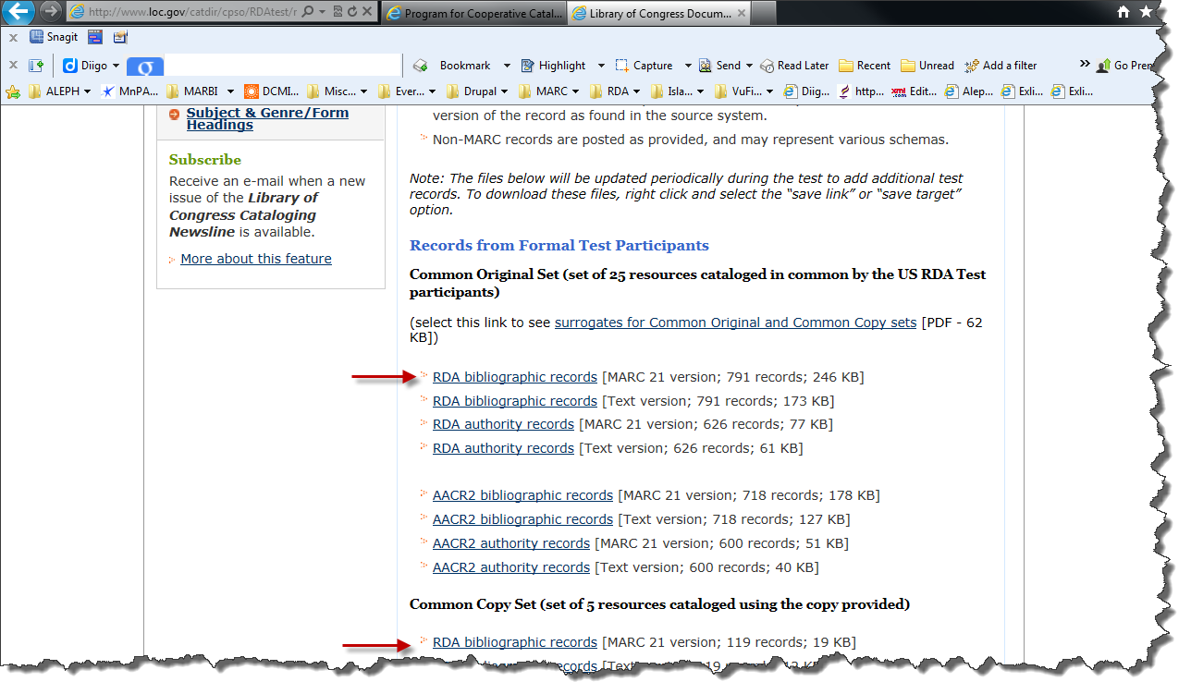

Open, Save, or Save as the record. Save as will allow you to place the file wherever you want it for uploading into Evergreen.
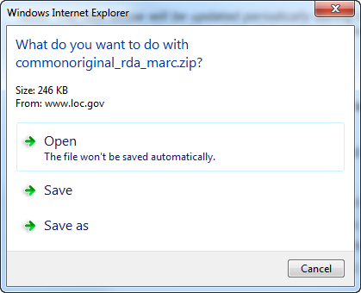
Save the file in the appropriate folder.
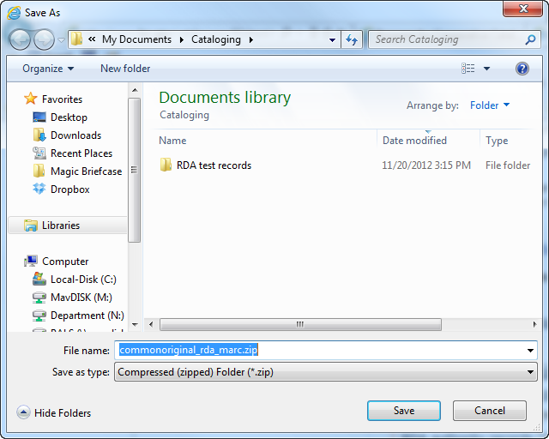

Importing records into Evergreen
To import the file of RDA test records into Evergreen, click on MARC Batch Import/Export from the main Evergreen page.
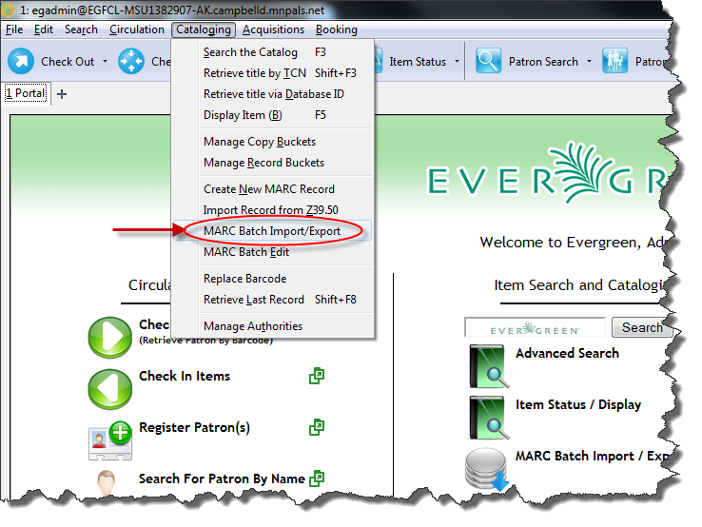

This is the Evergreen Batch Import/Export page:
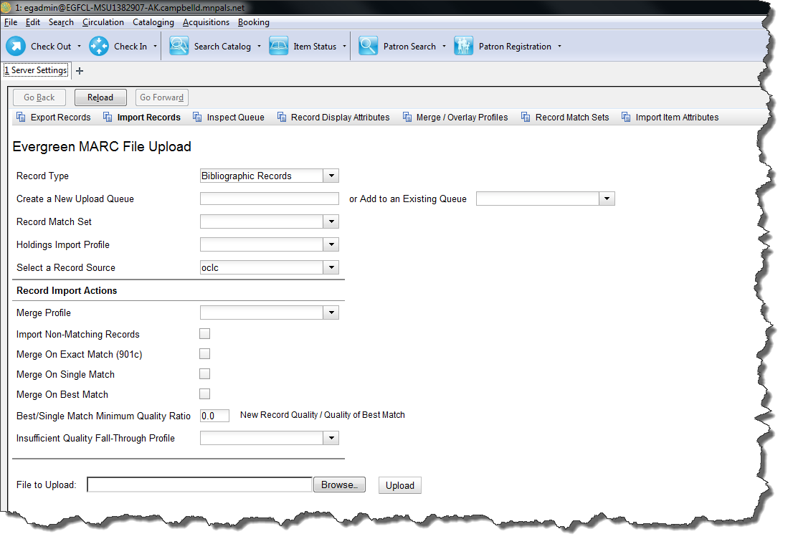
To import the file of RDA test records:
First select the record type from the drop down menu. The default is Bibliographic records.
Name a new upload queue. This is useful for later, because it is possible to import sets of records to the same queue if desired. For the record source, change it to System Local.
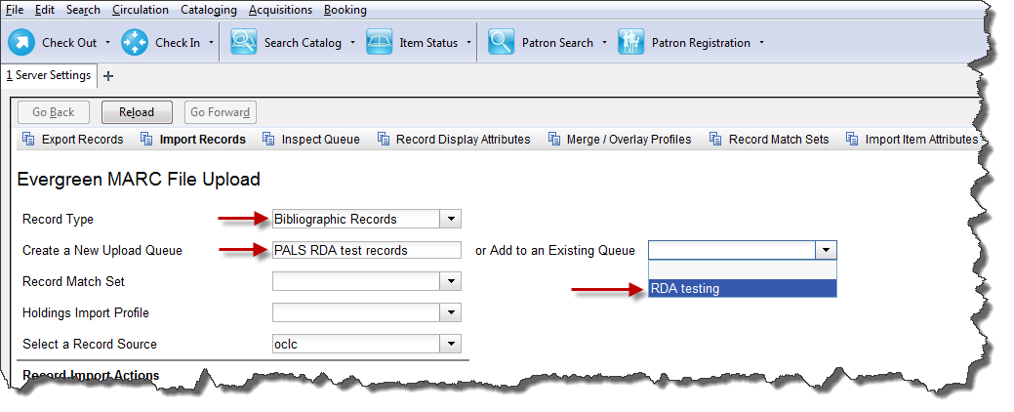

The options (Record a Match Set, Holdings Import Profile, and Select a Record Source) in the Evergreen MARC File Upload area and the Record Import Actions area are optional.
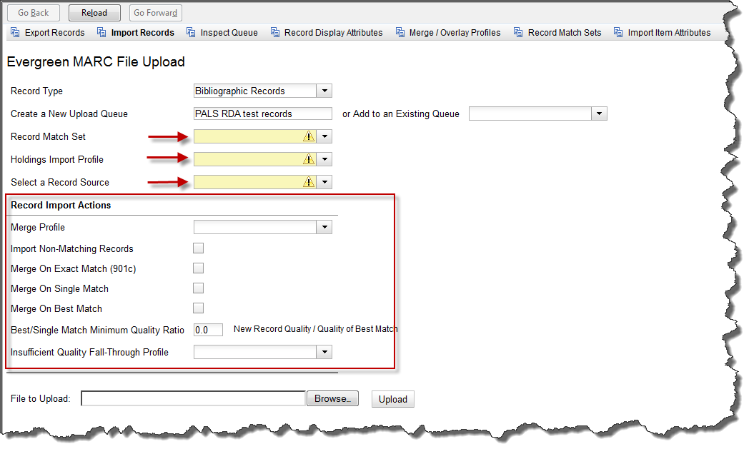

Upload the file to be imported by clicking on Browse and searching for the file.
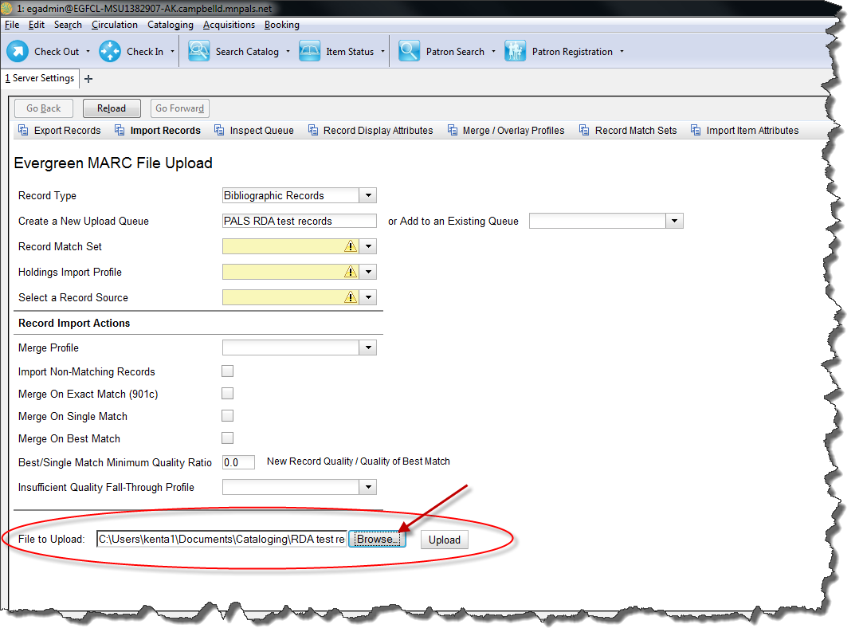
The import process after clicking upload may take a few minutes. This is the screen that appears as the file is being uploaded. This process may take several minutes. If it times out, try again.
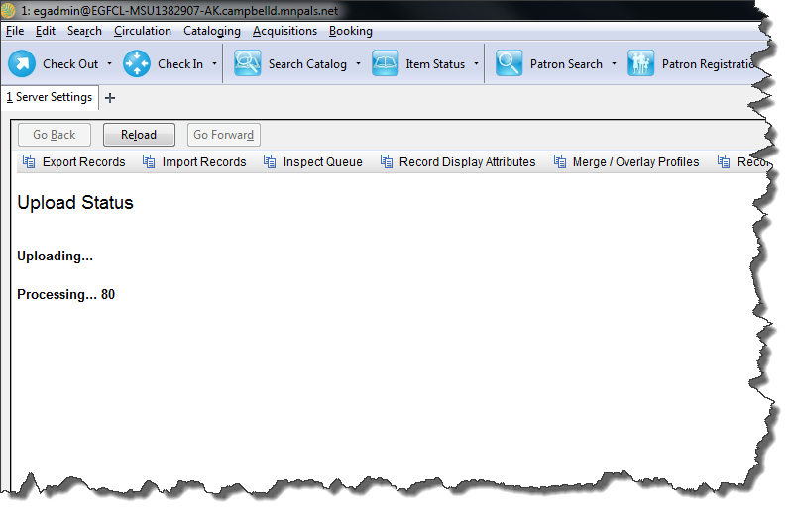
This is what appears after the file is uploaded. Check the Records in Queue under the Queue Summary to see the total number of records that were uploaded.
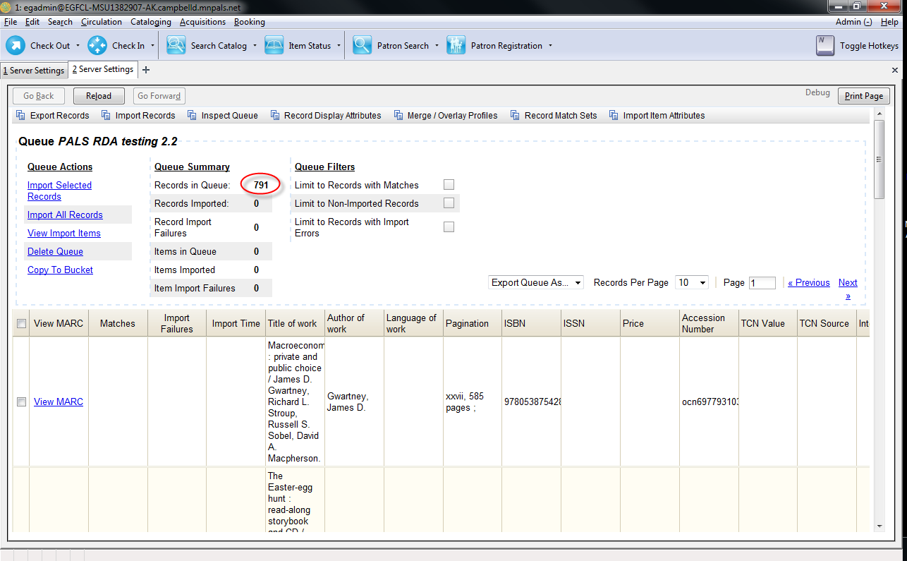

Several functions are available from the Queue Actions area. From here it is possible to import the entire file of 791 records, import a selected number, delete the queue, view the imported items, or copy them to a bucket.
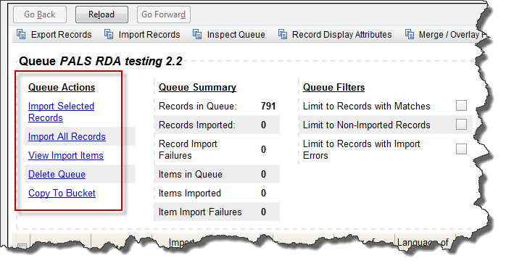
It is important to remember that at this stage nothing has been imported to Evergreen yet. It is sitting in a queue waiting to be imported.
To import all the records, click on Import All Records.
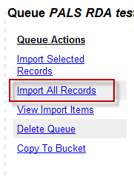

To import single records, click on the box next to the View MARC. This can be done multiple times.
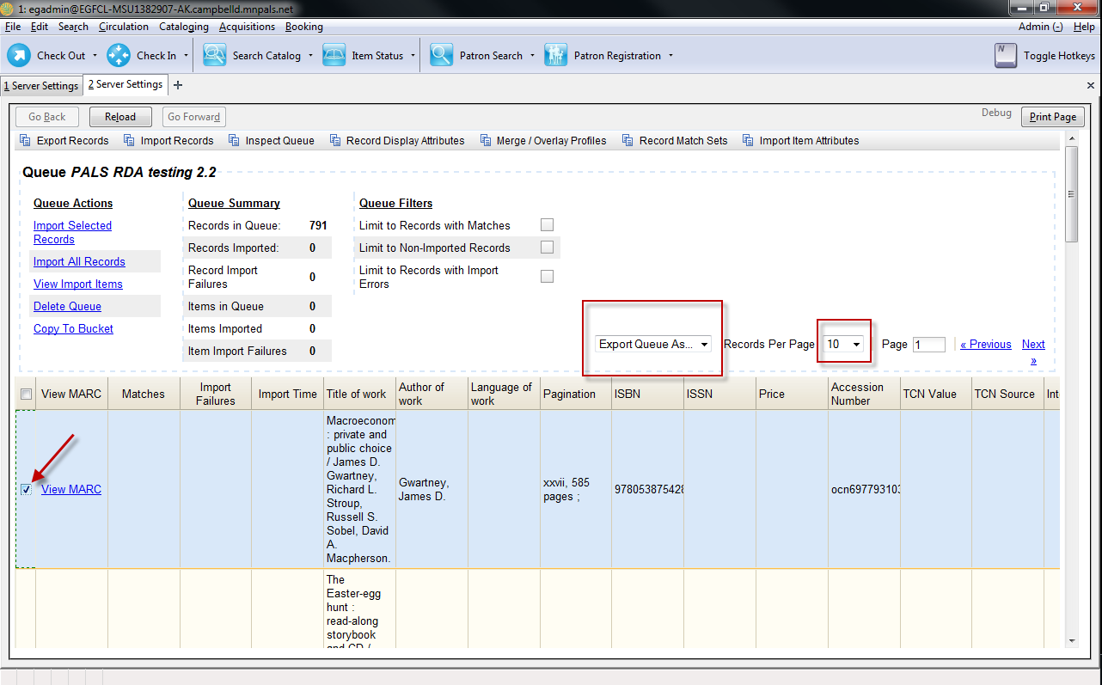

It is also possible to export the queue as Print, CSV, or have it emailed. Click the drop down menu (the black arrow pointing down) to bring up the options next to Export Queue As. It is also possible to change the number of pages (increase the number of records visible) shown on the screen. Click on the drop down menu next to the records per page option.
When finished selecting records, click on Import Selected Records.

This dialog box appears:
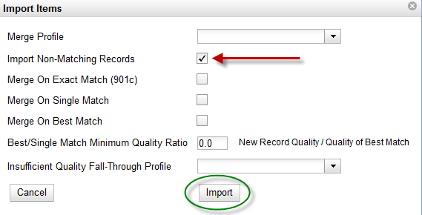
If you do not want this import to merge with any existing records in the catalog, click on Import Non-Matching Records. Leave the other options blank. Then click on Import.
A progress bar appears:
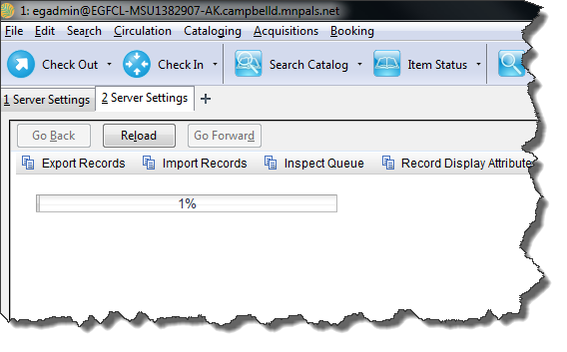
The import may take a several minutes depending on the size of the batch. Click on Reload if it times out. This will take the user back to the MARC batch Import/Export screen.

Large files (circa 700 or so records) may time out at 65%. If this happens try breaking up the batch load into smaller segments. Click on Reload to start over.
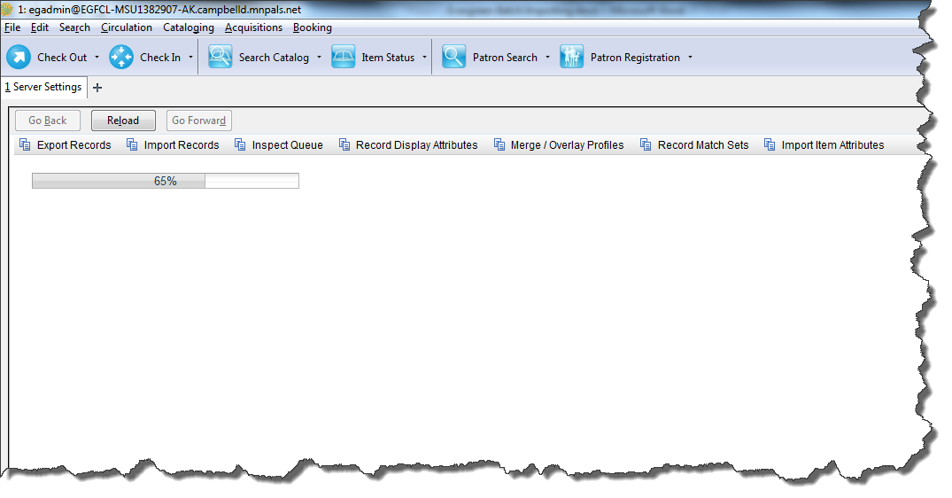
Searching for RDA records in Evergreen
A good way to search for RDA records in Evergreen is through the Advanced Search. Click on Advanced Search, then Expert Search. Enter 040 in the Tag, e for subfield, and rda for value.
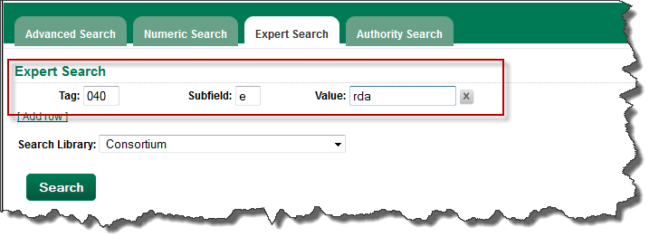

Getting RDA records from OCLC WorldCat for testing in Evergreen
I have also searched for RDA records in OCLC Connexion, exported them to a file, and then imported those records to Evergreen for testing. Some search strings I have used in WorldCat to get RDA records:
Searching for RDA records with personal name Stephen King:
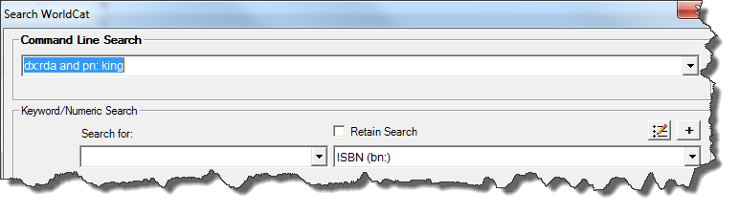
RDA records with baseball in the title gets a good result set:
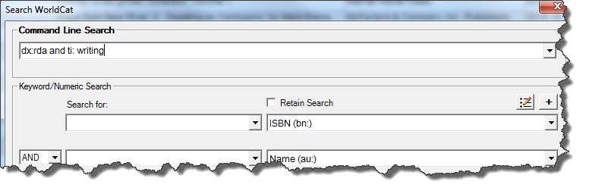
A good way to search for RDA records is to use the command line dx: rda and ti (for title) followed by anything you want in the title.
Hope this has been useful!

Contact info:
Alex Kent
Cataloging and Metadata Support and Training Specialist, PALS
Email: alex.kent@mnsu.edu

