Report 1: Displays count of items by circ modifier and shelving location. Filters out deleted items. Other filters include circulation modifier, shelving location and owning library.

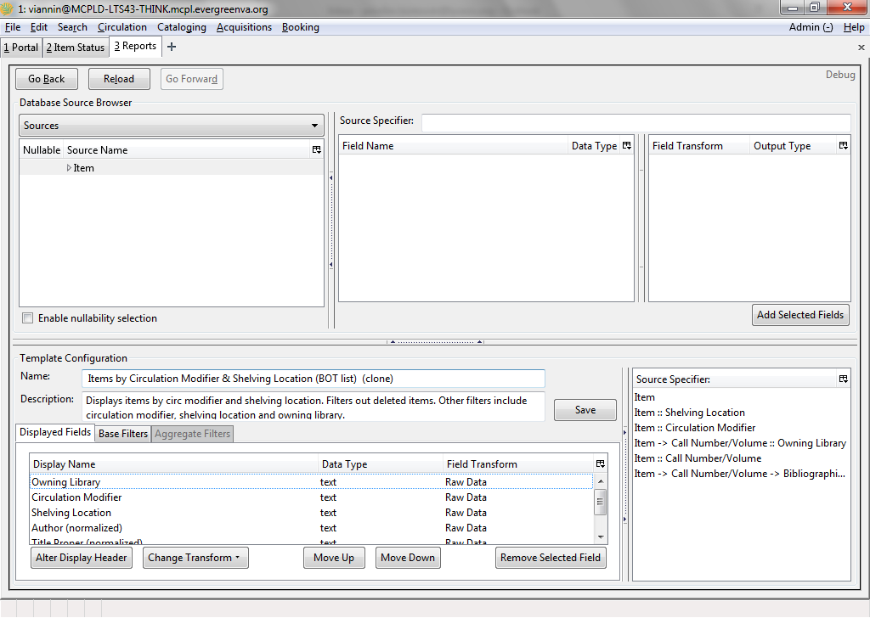

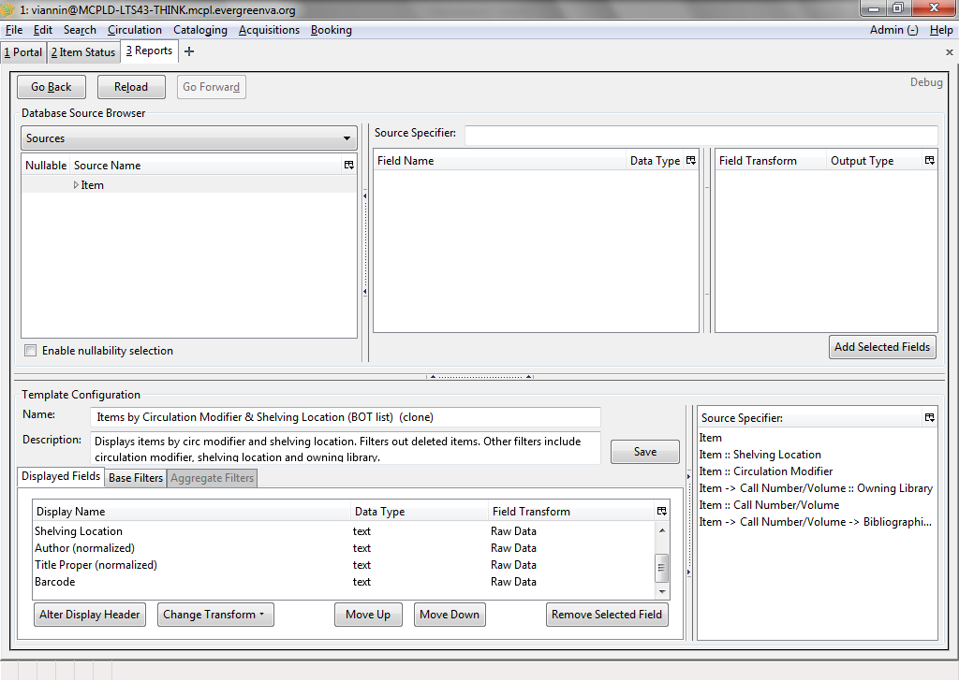

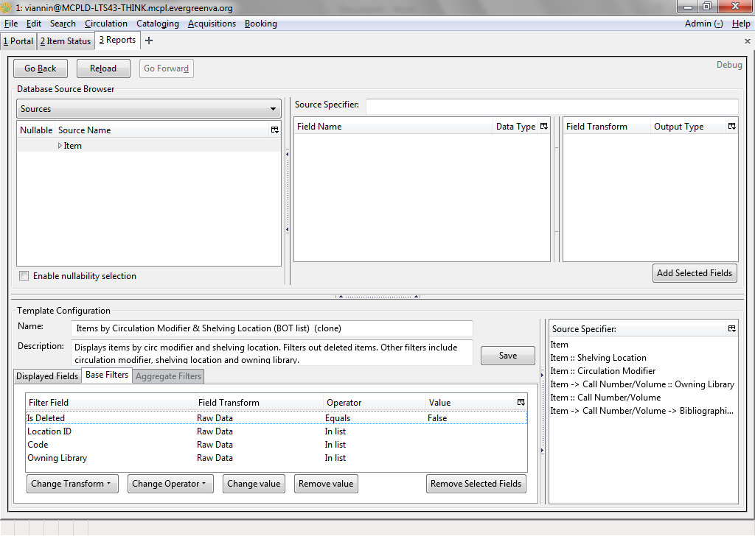

Report 2: Breaks down # of bibliographic/title records with holdings at specific libraries. Filter by owning library. Includes only active records that have not been marked as deleted.

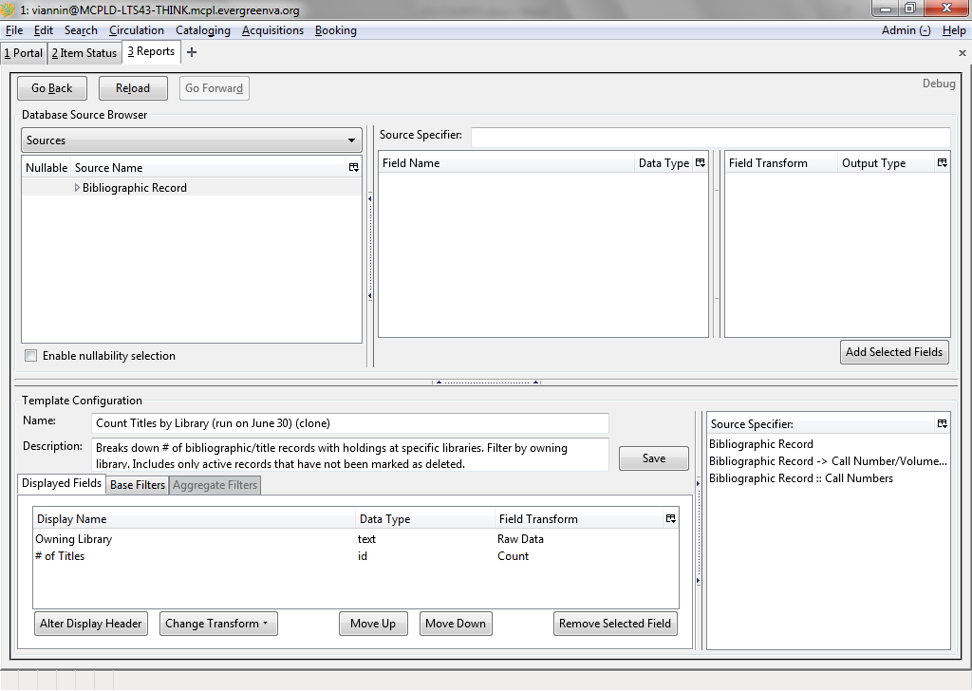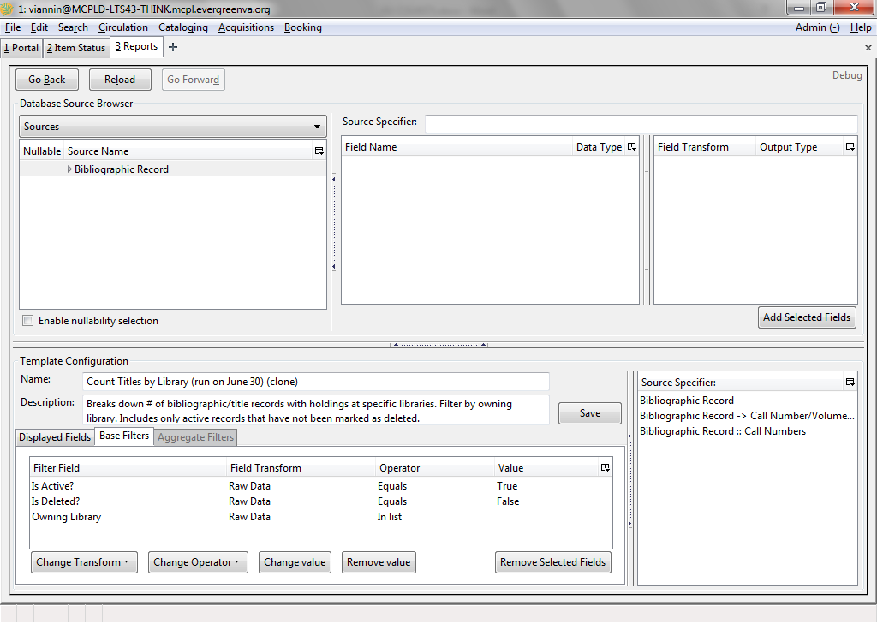

Report 3: Includes count of item/copy level records that have not been deleted from the system broken down by owning library. Filter includes owning library and the Is Deleted? flag.

