Pick up and Return Booked Resource

Pick up Booked Resource

Go to Booking Menu—Pick Up Reservations and enter patron’s barcode
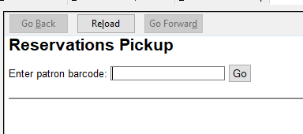
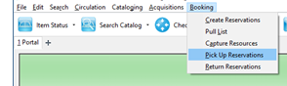

Or go to Patron’s Record—Other—Booking—Pick Up Reservations
(Using this method will automatically enter the patron’s barcode and is easier if you are entering several bookings for the patron.)
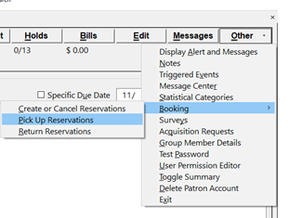

Patron’s name will be listed with items ready to be picked up at that location.

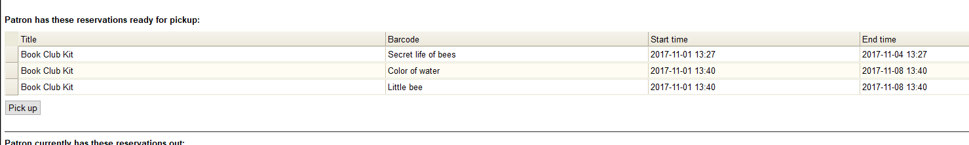

Click on the item to be picked up or hold down the control key and click on more than one item. Click the Pick Up button.

Item(s) that was picked up will be listed below the Pick Up button

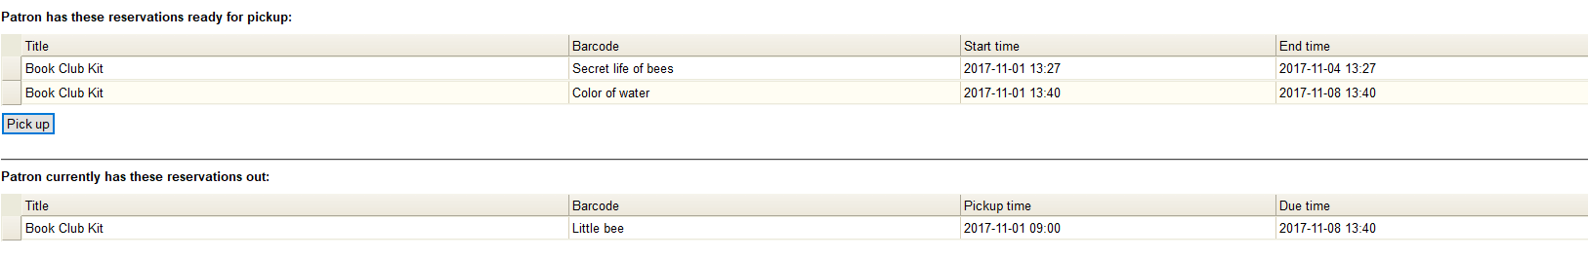

Return Booked Resource

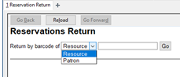
Go to Booking Menu—Return Reservations and enter either the resource barcode or the patron’s barcode
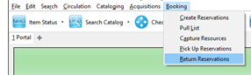

If you type in the item’s barcode, it will return the item. Below the patron’s name, the screen will show what booked items the patron still has out. Below the Return button any resources that were returned that day will be listed.
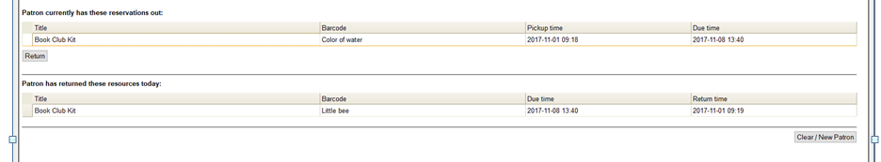

Or go to Patron’s Record—Other—Booking—Return Reservations
(Using this method will automatically enter the patron’s barcode and is easier if you are returning several bookings for the patron.)

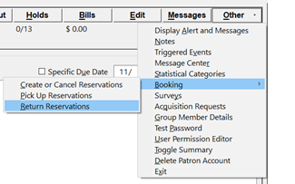

Under the patron’s name, any Booked items the patron has out will be listed.

Click on the item to be returned or hold down the control key and click on more than one item. Click the Return button.

Item(s) that was picked up will be listed below the Return button
