DYMO Printer Settings:
Go to Admin Workstations Administration Printer Settings Editor

Initial Label Printer Setup:
Update settings as described below. When finished, close the window and proceed with label configuration.

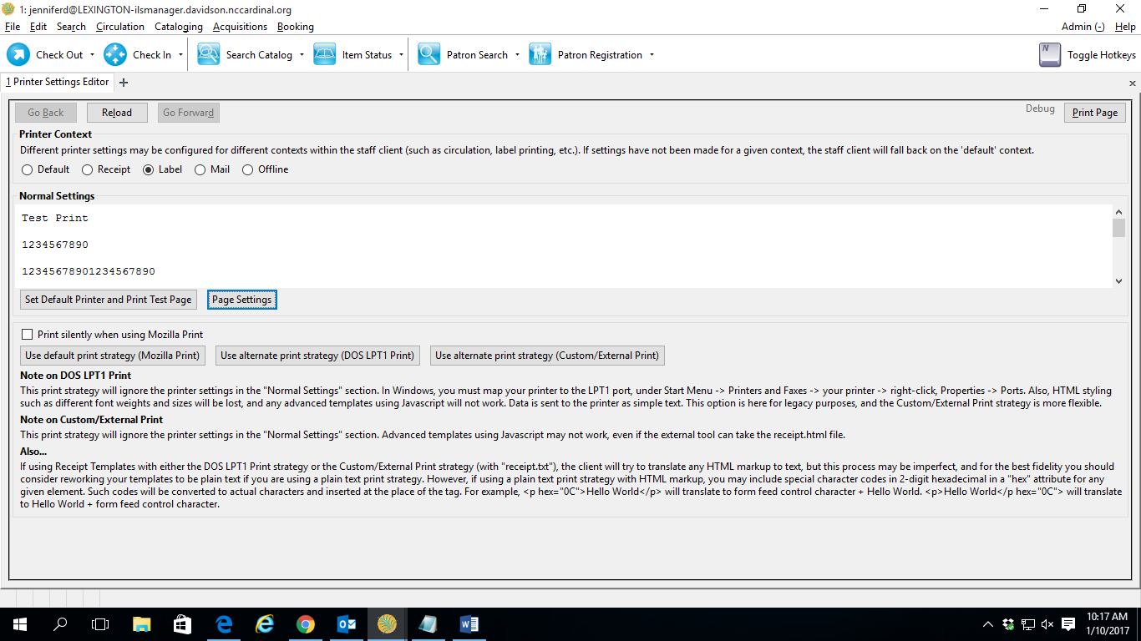
3. Click on Default Printer and Print Test Page
Choose DYMO Printer and Click “OK” to print a test label. Make sure label printers horizontally. Font will be small and very light. You are just testing connection and orientation.
2. Open Page Settings
- Choose Label
On Format & Options tab:
Orientation = Landscape

On Margins & Header/Footer tab:
All margins set to 0.0
Everything else should be blank

Label Configuration:
Open the Item Status screen. Find an item to use as an example.
Choose Actions for Cataloger Print Spine Label
If you make changes to the settings, click on Re-Generate to display the revised format.
You can make changes to a label before printing after you click on Preview and Print.
Settings for the standard configuration are shown below.

