Item status in XUL. Hovering over circ counts shows counts for each year.
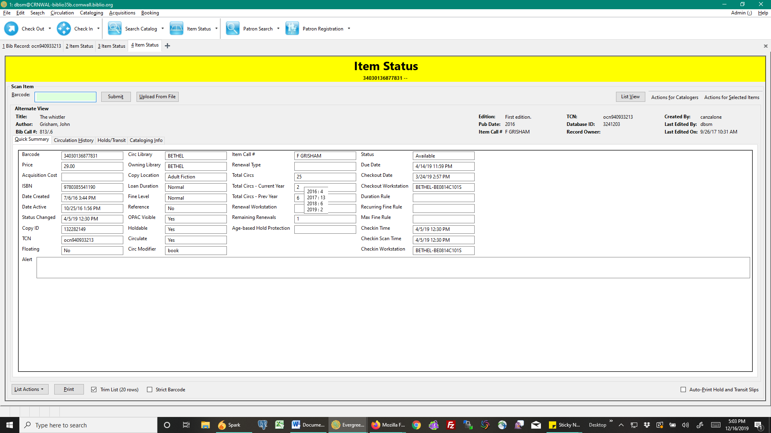
Web client. Can’t get the same historical circ count information in Item Status.
