The Evergreen Community Outreach Committee has come up with some Evergreen Logo update options and would like the community to cast their vote. The new updated logo will allow for resizing, be able to be used on a variety of background colors and still be recognizable.

Option 1
Yes___ 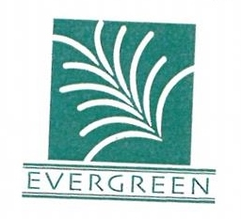
No____

Option 2

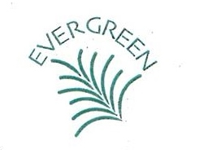

Yes____
No____

Option 3
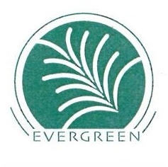

Yes___
No___

Option 4

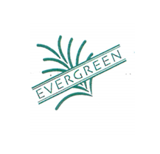

Yes___
No___

Thank you for taking the time to fill out the survey. Give yourself the brownie points you deserve.

